GRAPH AND SEARCHING (DFS AND BFS)
Code:
#include <stdio.h>

int a[10][10], n, visited[10];

void dfs(int v)
{
int i;
printf("%d ", v);
visited[v] = 1;

for(i = 0; i < n; i++)
{
if(a[v][i] == 1 && visited[i] == 0)
{
dfs(i);
}
}
}

void bfs(int start)
{
int q[10], front = 0, rear = 0;
int visited[10] = {0};
int i, v;

q[rear++] = start;
visited[start] = 1;

while(front < rear)
{
v = q[front++];
printf("%d ", v);

for(i = 0; i < n; i++)
{
if(a[v][i] == 1 && visited[i] == 0)
{
q[rear++] = i;
visited[i] = 1;
}
}
}
}

int main()
{
int i, j, start;

printf("Enter number of vertices: ");
scanf("%d", &n);

printf("Enter adjacency matrix:\n");

for(i = 0; i < n; i++)
for(j = 0; j < n; j++)
scanf("%d", &a[i][j]);

printf("Enter starting vertex: ");
scanf("%d", &start);

printf("\nDFS: ");

for(i = 0; i < n; i++)
visited[i] = 0;

dfs(start);

printf("\nBFS: ");
bfs(start);

return 0;
}
OUTPUT: 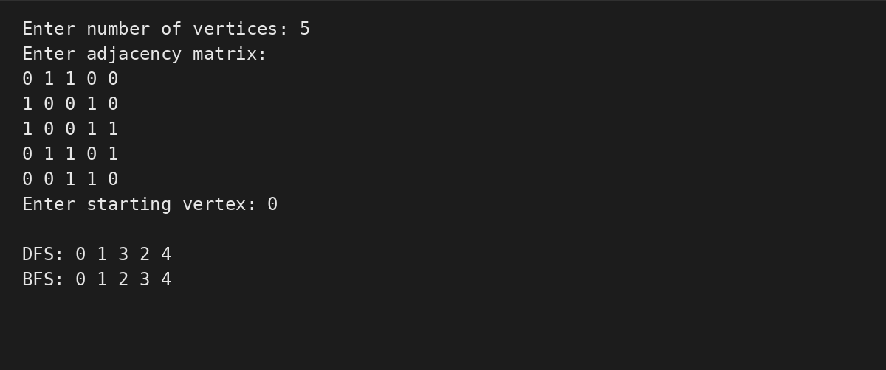

Conclusion:
Complexity | Value
Time Complexity | O(V + E)
Space Complexity | O(V)

